GIT & GITHUB

Git and GitHub are different things.

Git -

Github –

GitHub is a Git repository hosting service.

1. ***Creating Repository using GUI***

**Step -1 Create Repository**

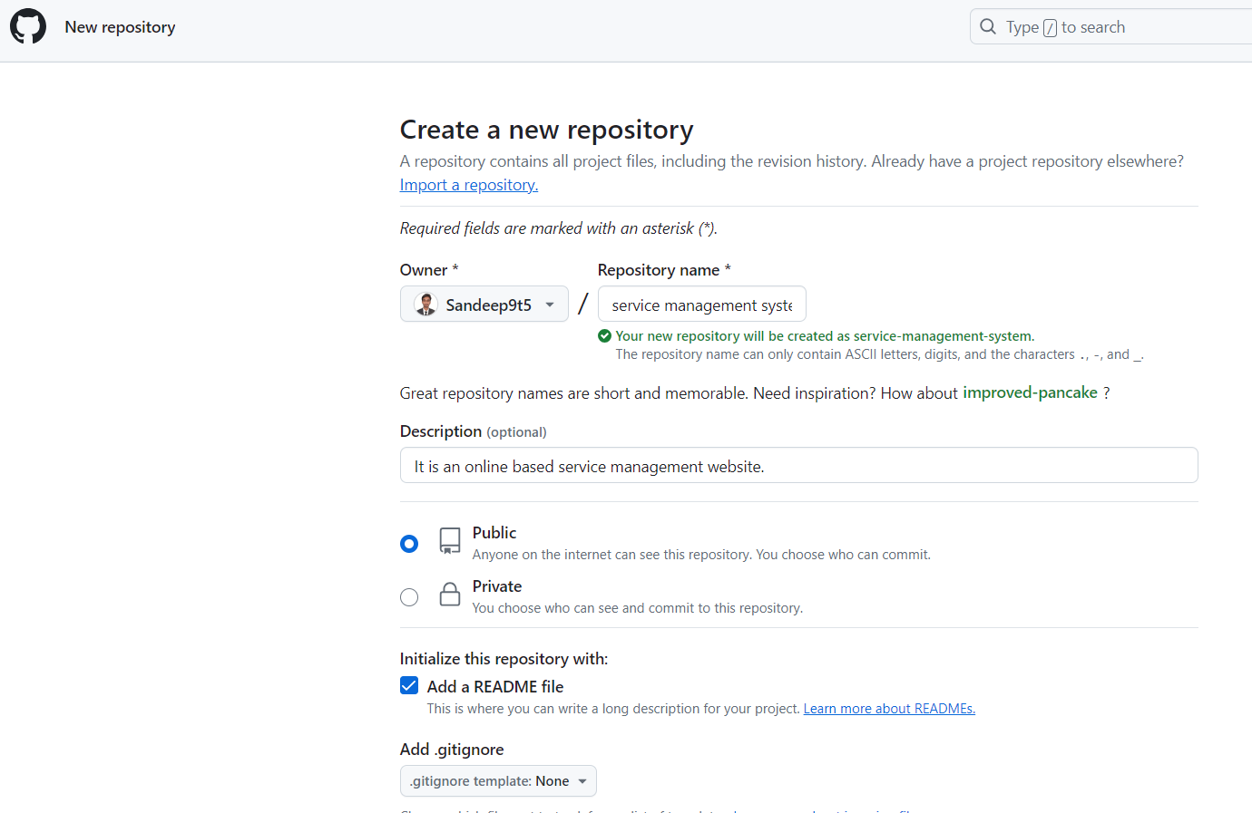

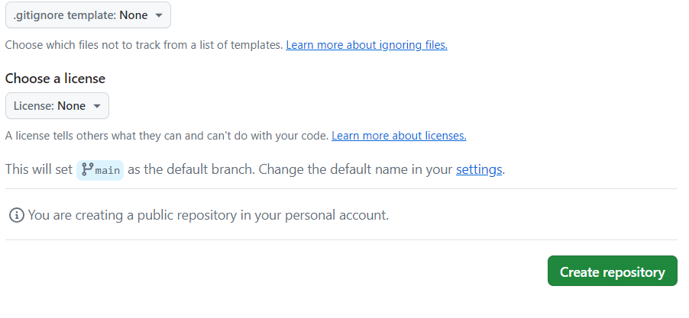

**Step -2 Upload files to the repository**

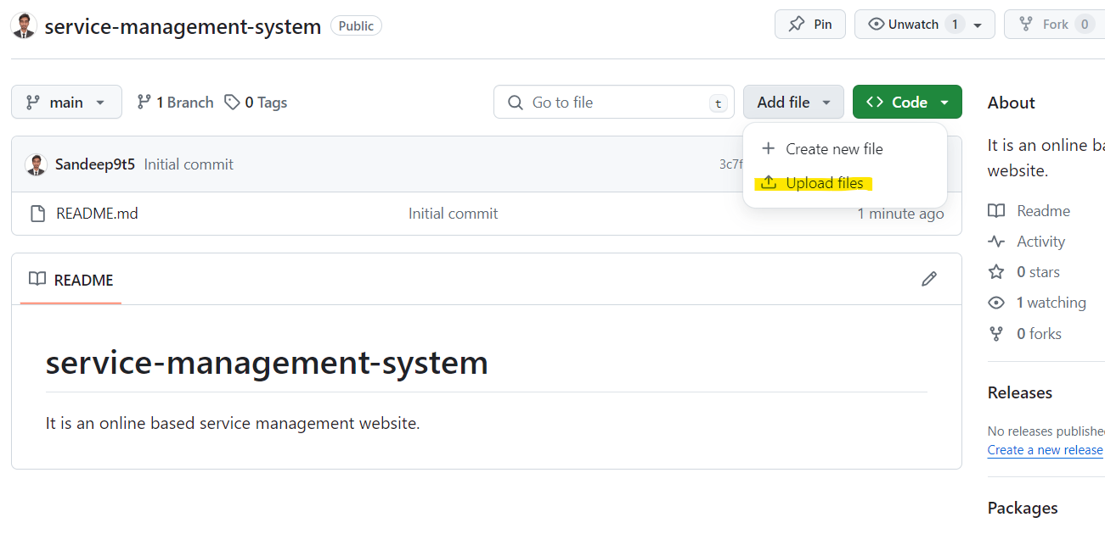

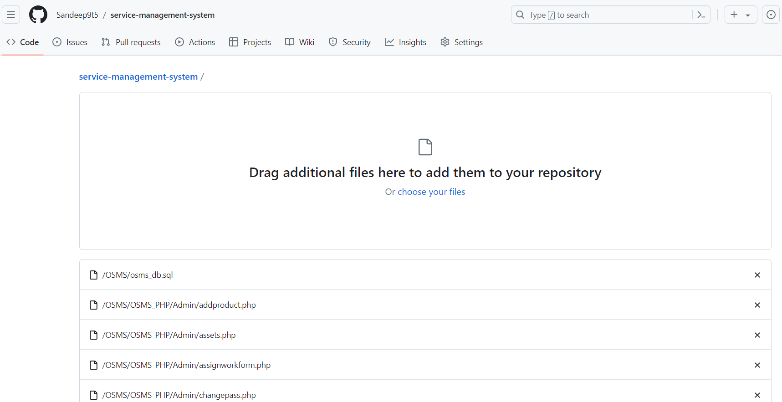

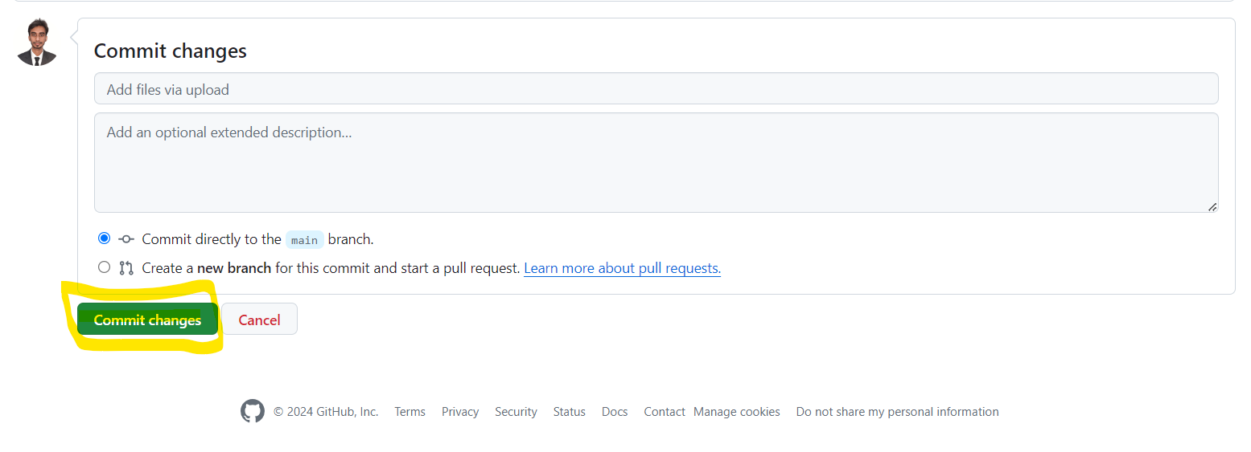

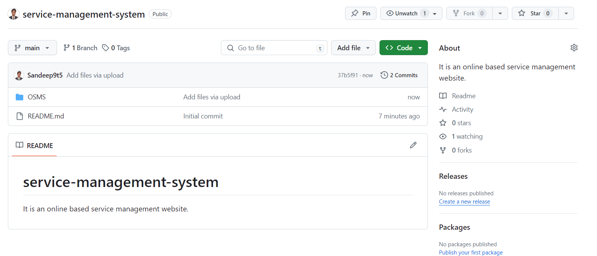

***How to download any Repository using ( GUI )***

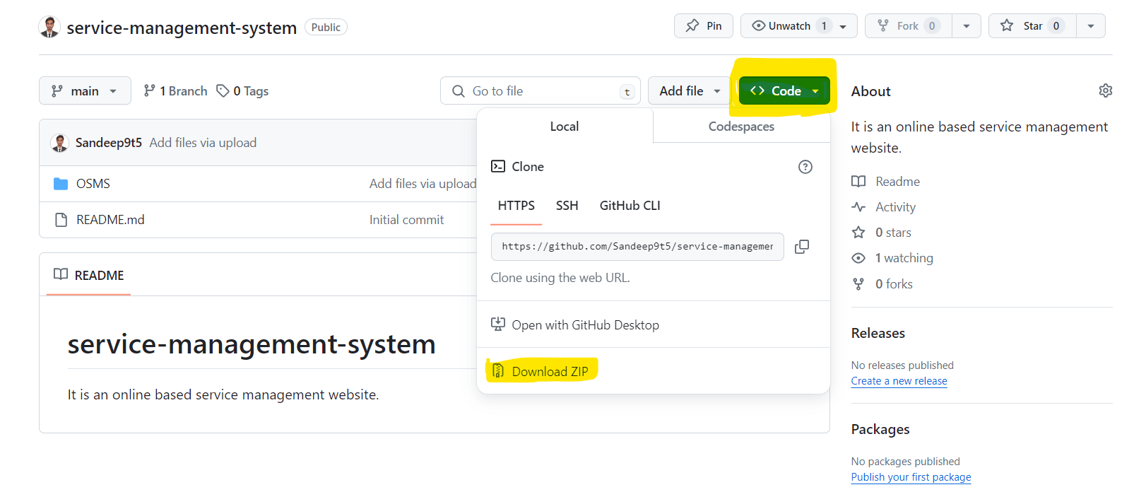

***How to download any Repository using ( CLI )***

$ git clone <https://github.com/Sandeep9t5/learnwap.git>

1. ***Creating Github repository by using git bash ( CLI MODE )***

**Step -1 Create Repository**

**Click on github icon ---> click on new ---> give the name of repository ---> create repository**

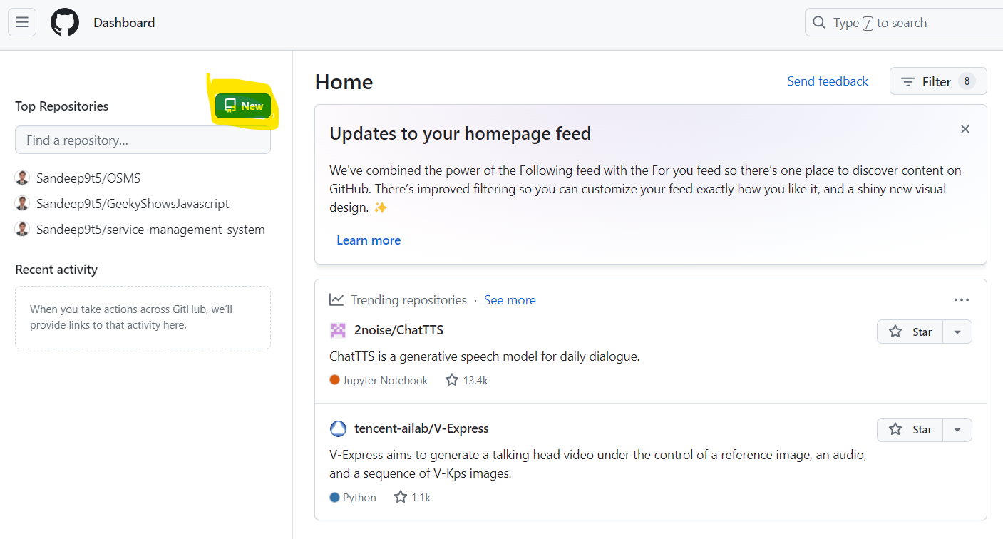

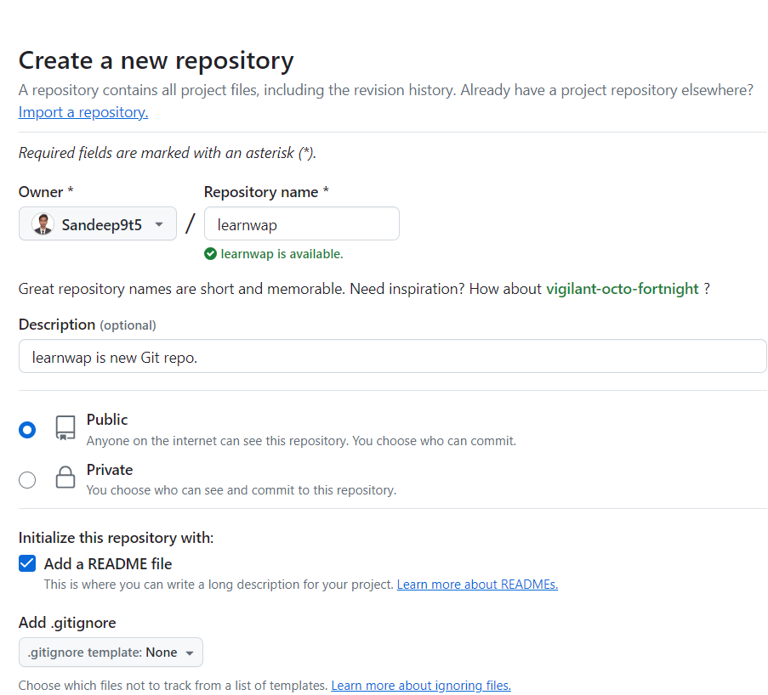

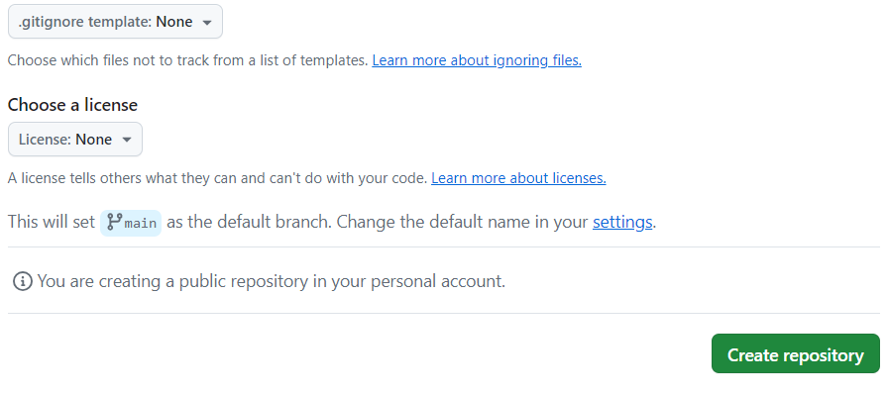

**Right click on the folder and select open with gitbash here-**

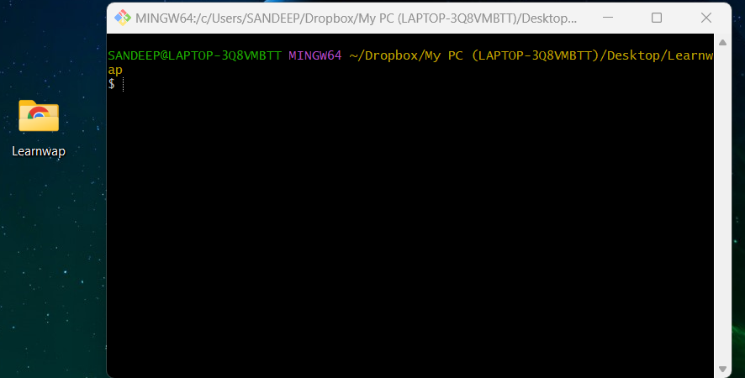

***Git Commands***

Step 1. Initialize the Git into the working repository

Step 2. Add the files

Step 3. Mention the comments

Step 4. Select the Github Repository

Step 5. Push the code

1. git init
2. git add index.html or git add .
3. git commit –m “First release of hello world”
4. git remote add origin <https://github.com/Sandeep9t5/learnwap.git>
5. git push origin master
6. git config --global user.name “Sansri”
7. git config --global user.email “sansri150796@gmail.com”
8. git status
9. git log

**To add something or to update something in files or to upload for second time**

Step 1. Add the files

Step 2. Mention the comments

Step 3. Push the code

1. git add .
2. git commit –m “second release of hello world”
3. git push origin master

**Adding files to github repo for the first time**

1. **To initialize git in the folder -** **( git init )**

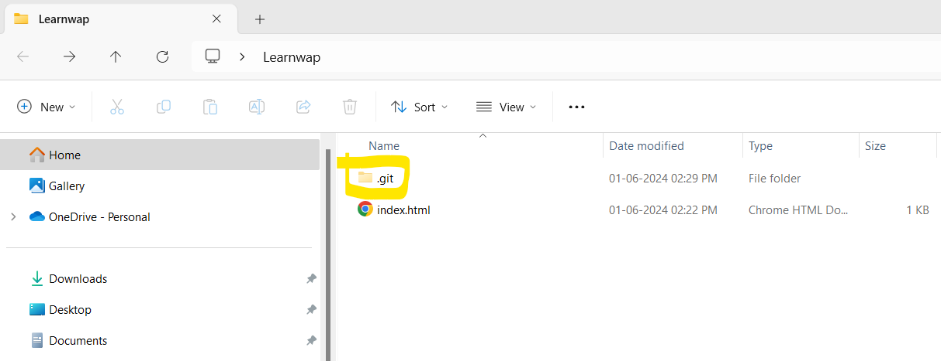

1. **To select the files which needs to be added -** **( git add index.html )**
2. **To add the comments -** **( git commit –m “First release of hello world” )**

*Ye batata hai is file ke andar hai kya*

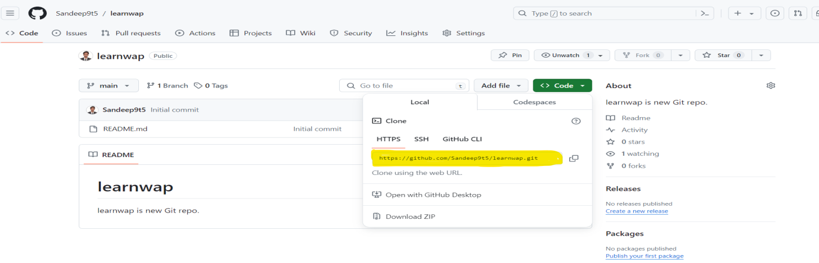

1. **To select the repository in which files needs to be uploaded -**

**git remote add origin** <https://github.com/Sandeep9t5/learnwap.git>

1. **To Push the files into repo - (**  **git push origin master )**

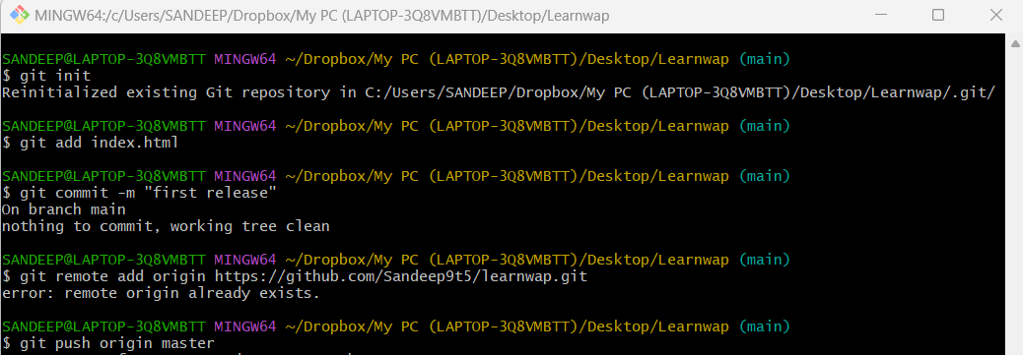

**Adding 1 more file to that same repository in github**

1. **To initialize git in the folder -** git init **( no need as file is already initialized )**
2. **To select all files in fact it will select the remaining also of that folder -** git add .
3. **To add the comments -** git commit –m “second file upload”
4. **To select the repository in which it needs to be uploaded –**

**( no need as github repo is already selected )**

git remote add origin <https://github.com/Sandeep9t5/learnwap.git>

1. **To Push the files into repo -** git push origin master

**Video: 4**

***To create new branch and push the code into that account***

**1. Rahul ( master )**

**2. Saurav ( User )**

**3. Kamal ( User )**

**Saurav user**

1. git status
2. git add .
3. git commit –m “Third release of hello world”
4. git checkout –b saurav
5. git push origin saurav

**Kamal user**

1. git status
2. git add .
3. git commit –m “Third release of hello world”
4. git checkout –b kamal
5. git push origin kamal

**Video : 5**

**Connect web cpanel with the git-**

1. Create new Repository – studentwap

2. Create website folder – studentwap

2.1 Create index.html inside studentwap folder.

2.2 Create .cpanel.yml inside studentwap folder.

---

deployment:

tasks:

- export DEPLOYPATH=/home/example/public_html/

- /bin/cp * $DEPLOYPATH

1. Right click and open git bash and execute the commands
2. git init
3. git add .
4. git commit –m “First release of my website”
5. git remote add origin <https://github.com/Sandeep9t5/studentwap.git>
6. git push origin master

go to cpanel – > click on File Manager -> click public_html -> select all files and delete it

click on git version control under the cpanel -> create -> url <https://github.com/Sandeep9t5/studentwap.git> -> repository path ( public_html ) ->create -> manage ->update ->pull or deploy ->update from remote -> deploy head commit

search on browser - studentwap.com

**Video:6**

1. **To download the project from github-**

Right click and open git bash here

git clone <https://github.com/Sandeep9t5/studentwap.git>

1. **Open that folder into the code editor**

check the branch by Right clicking and opening git bash here, if it is in master branch then for creating a new branch -

git checkout –b Todayswork ( branch Create krega and shift krega created branch pr)

**Note:** If we create any new brach then the previous branch code is copied to the newly created branch.

update the code or add some code if needed then-

1. git add .
2. git commit –m “new line added”
3. git push origin Todayswork

select the branch in github and see the changes.

**Shifting the branch in the git-**

**Right click and open git bash here**

To go into Todayswork branch to the master branch

1. git checkout master

**To go into Todayswork branch**

1. git checkout Todayswork

If the codes are finalized then we can shift all the Todayswork branch code to the master branch by merging it-

Go to the master branch and Merge the codes

1. git checkout master
2. git merge Todayswork

Then we will not be needing Todayswork branch any more as the work is done and shifted to master branch so we can delete Todayswork branch and if we need to update anything then we can create new branch and do so.

**To delete the created branch**

git push origin -- delete Todayswork

**Note :**

git branch demo - This will create the branch

git checkout demo – To select the the branch

git checkout –b demo – This will create and select the branch

**Video : 7**

**Commands**

Create your branch first code will be copied automatically then starts working on it.

1. git checkout –b Todayswork
2. git branch –a ( there are two types of brances local and remote)
3. make changes in the file
4. git add .
5. git commit –m “new line added”
6. git push origin Todayswork

If the codes are finalized then we can shift all the Todayswork branch code to the master branch by merging it-

Go to the master branch and Merge the codes

1. git checkout master
2. git merge Todayswork

**To delete the created branch on remote server**

1. git push origin -- delete Todayswork

git branch -a

branch on remote server will be deleted but local will be there. We will delete it from local when new code is pushed to master.

1. git push

**To delete the created branch on local server**

1. git branch –d Todayswork

10. git branch -a

**Video 8 : Fork & Pull request**

**Fork :** Kisi aur ke github repository ko apne account me copy krna.

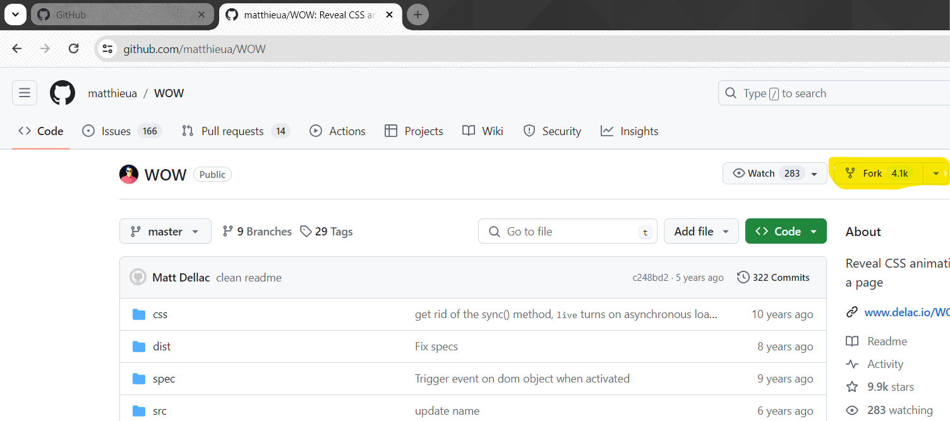

Clone the project to the local pc and make the changes you want.

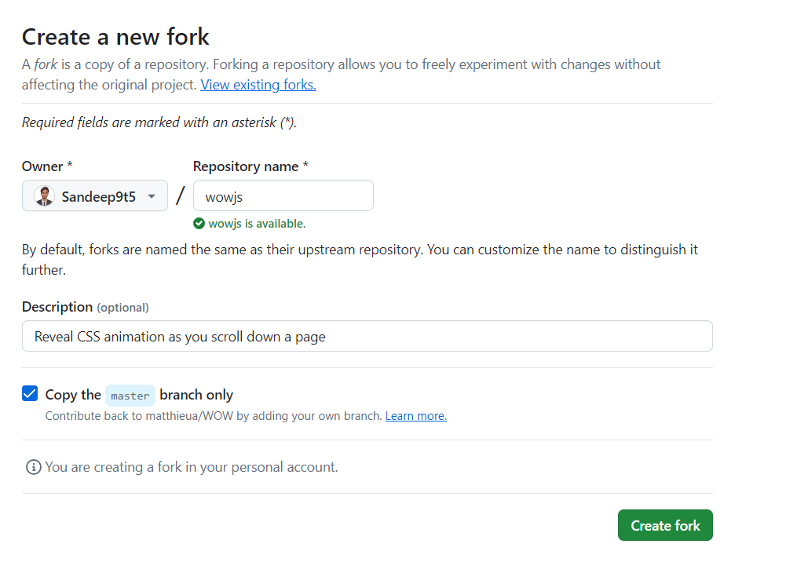

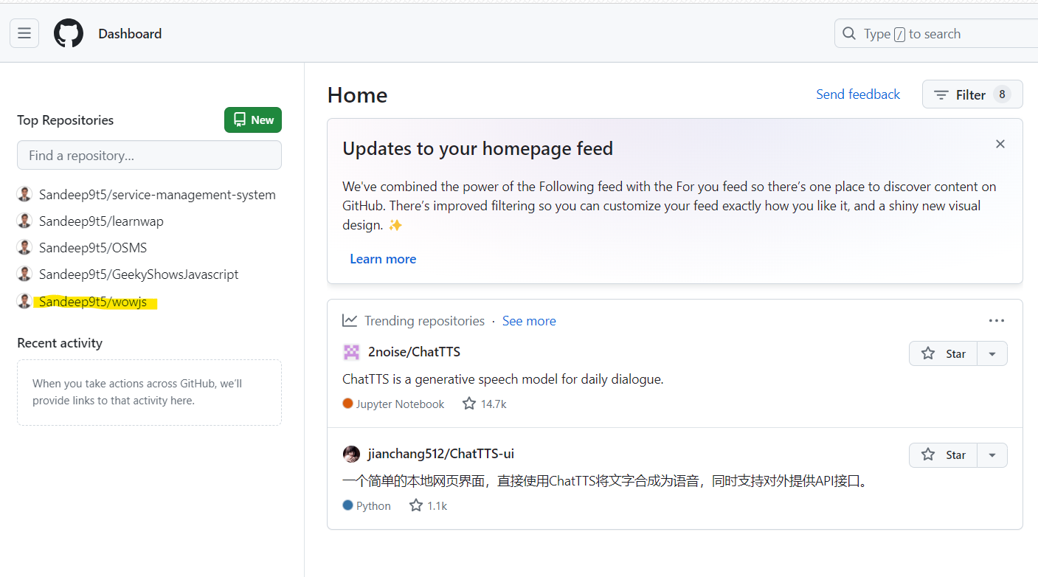

**Clone :** clone krne ka mtlab hai github repository se download krna apne local pc ke andar project ko.

Right click and open git bash here on the desktop.

Sara project text code pc me download ho kar aajayega - **git clone** [**https://github.com/Sandeep9t5/wowjs.git**](https://github.com/Sandeep9t5/wowjs.git)

Then open that project in code editor and start making changes in the project

**Pull request :** Pull request ka matlab hai hmm request krenge wow js se ki jo hmne changes kiya hai usko observe kijiye kya apko sahi lag rha hai toh fr aap apne master branch me use merge kr lijiye.

Right click and open git bash here.

1. We will create a new branch

git checkout –b fix-by-sandeep

1. Push the files
2. git add .
3. git commit –m “Title has been changed”
4. git push origin fix-by-sandeep

**Go to Github console -> click on Compare & Pull request -> add the comments and then click on Create pull request.**

Jaise hi hmne pull request pr click kiya automatic wow js ke github account me pull request ka msg jayega.

Agar jo apne pull request kiya usko dekna hai toh fr search -> wow js github -> click on pull request

**Video : 9 Versions (Tagging)**

Version ko git ke sabdo me tagging ya git tag kha jata hai

1. ***Testing Version -***

Create a new repository

Right click and open git bash and execute the commands

1. git init
2. git add .
3. git commit –m “Beta version launched”
4. git remote add origin <https://github.com/Sandeep9t5/e-commerce.git>
5. git push origin master

**Note:** Agar aap chahate ho ki haar code ka record alag-alag rkhna tb ek new version ko release kr doge.

***Adding versions in GIT Bash***

1. **git tag v1.0.0-beta** - local computer me tag create hua
2. **git push origin** **v1.0.0-beta** - version created on Github under Tag section

***Making next-versions -***

Right click and open git bash and execute the commands

1. git add .
2. git commit –m “Some changes in Beta version”
3. git push origin master
4. git tag v1.0.1-beta
5. git push origin v1.0.1-beta
6. ***Stable version Release-***

Jab apko lgta hai code perfect hai production me jane ke liye and ab koi bug nhi hai toh fr stable version nikal kr github me push kr dijiye.

Right click and open git bash and execute the commands

1. git add .
2. git commit –m “First Stable version”
3. git push origin master
4. git tag v1.0.0
5. git push origin v1.0.0

**Video: 10**

1. **To download the project from github-**

Right click and open git bash here

git clone <https://github.com/Sandeep9t5/studentwap.git>

2. open that project in the code editor.

3. Right click and open git bash here

4. git tag

5. git checkout v1.0.1

1. git add .
2. git commit –m
3. git push origin master
4. git tag –a v1.0.2 –m “h1 color changed”
5. git push origin v1.0.2

***Checking that all versions are present if we create any new branch.***

Right click and open git bash here

Agar koi branch create krenge toh master ka codes with all tags will be copied into the newly created branch

git checkout –b “work”

git tag

***To delete any Tags***

Right click and open git bash here

git tag –d v1.0.0-beta v.0.0.1-beta ( delete locally )

git push origin –d v1.0.0-beta v.0.0.1-beta ( delete from github )

Video: 11 Organisation

***Deleting the repository from Github***

